
Module 10: Ending the Relationship – Participant Handbook

Module 10 Resources: 2
Information from Module 10 Slides: 3
Homework to be completed before the Module 11 session 5
a) Homework Activity 5
b) Homework Reading 5

Module 10 Resources:

PeerWorks currently has three Communities of Practice available for our members/member organizations. Each CoP meets once a month:
- Peer Support Workers who work in hospital settings.
- Peer Support Workers who work in the MAPS program or elsewhere in the criminal justice system.
- There is also a CoP for people who have taken PeerWorks’ Peer Support Core Essentials Training.
https://www.peerworks.ca/members/member-services

Information from Module 10 Slides:

Concluding the Relationship is bringing closure to a Peer/Peer Supporter relationship. This can involve:
- Acknowledging the end of the formalized relationship between the Peer and the Peer Supporter.
- Assisting the Peer during the transition between the conclusion of the formalized Peer/Peer Supporter relationship and the Peer’s next step.
- Reflecting on the lessons learned from the relationship between the Peer and the Peer Supporter.

Supporting Post-Relationship Transition
The ending of a relationship between a Peer and a Peer Supporter is a time of change for both the Peer and the Peer Supporter.
A Peer Supporter may support the transition by:
- Acknowledging the Adjustment
- Clarifying Next Steps
- Instilling Confidence

Community of Practice
A Peer Support community of practice is a group of people who share a concern and passion for peer support and learn how to do it better as we interact regularly.
CoPs often focus on sharing best practices and creating new knowledge to advance a domain of professional practice. Interaction on an ongoing basis is an important part of this. A community’s specific purpose and goals inform the appropriate activities and technologies to support it. Many virtual communities of practice rely on face-to-face meetings and Web-based collaborative environments to communicate, connect, and conduct community activities.

Michael Smith Foundation for Health Research - Guide for Communities of Practice

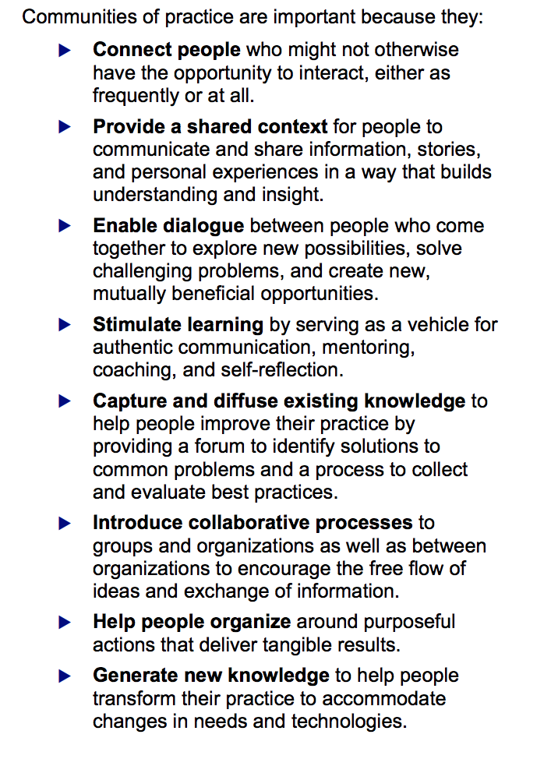

Homework to be completed before the Module 11 session

Homework Activity (Should take 10-15 minutes):
Write a reflection on what you have learned from the modules so far. This can mirror the type of reflection you might write with your Peer at the end of a Peer Support relationship.
Prompts:
- What new knowledge have you gained about Peer Support?
- How can you apply this knowledge to your role/future role as a peer Supporter?
- What questions do you still have about Peer Support?

Please email your written reflections to [Training Coordinator] at [email@peerworks.ca]

Homework Reading (Should take 5-10 minutes):

Laura-Leigh’s Story

My name is Laura-Leigh Gillard (she/ her). I am a 39-year-old wife and proud mother of two.

For as long as I can remember, I have struggled with my mental health. As a child, I was sensitive and felt things very deeply. I still do.

There was a lot of tension in my home growing up. I was the first born to young parents trying their best with what very little they had. My Father was out of town quite often for work. When he was around, he was typically irritable or inebriated (quite often, both).

At school, I was quiet, self-conscious, and awkward, which made me an easy target for classroom bullies. I recall my anxiety manifesting as illness a lot during those years.

Adolescence presented a whole new set of challenges, as it so often does. At the age of 15, my parents’ impending divorce was the catalyst to a pattern of self-destructive behavior that spanned several years. I was caught in a vicious cycle of feeling lost, anxious, and overwrought with negative thoughts. I would often lay awake at night, analyzing my life, internalizing situations to the point of developing stomach ulcers from stress. It was around this time I was formally diagnosed with severe anxiety and depression and was prescribed medication.

By 17, troubling thoughts overpowered me to the point of developing agoraphobia. For six months, I was barely able to leave my home due to crippling anxiety and I needed to take a semester off high school. Day by day, I became more disconnected from family and friends and had never felt so alone. I felt deeply ashamed of how far my mental health had declined, and desperately wanted to feel “normal”.

After months of suffering, I finally made the decision to tell my doctor about what I had been experiencing. My journey to mental health recovery began then and there with my willingness to be honest about my situation, and my bravery in seeking help.

My family doctor referred me to a wonderful therapist who introduced me to meditation and various breathing techniques (some of which I still practice to this day). Exercising mindfulness and gratitude has played a significant role in my mental health recovery. It is through these practices I can remind myself that I am not my thoughts, nor my mind, and that whenever I’m feeling trapped, I remember that I’ve been there and have freed myself before.

There were days that took a tremendous amount of courage and conviction to stay on the path to wellness, but with the right guidance, and a continued effort, I began to understand my thoughts, feelings, and emotions on a deeper level. I started reading books on self-help and studying Eastern Philosophy to broaden my understanding of the human condition. I desperately needed to know why life was so hard, and how I could alleviate the pain.

As my recovery progressed, I began to feel pulled towards expressing these learnings in ways that could help make a difference in the lives of others. In January 2015, I took a leap of faith, and applied for (and accepted) the position of Telephone Peer Support Worker on the Regional Warm Line, which is a Peer-run, pre-crisis support line that provides support to thousands of callers struggling with mental health and addictions annually. While I didn’t quite know what Peer Support was at the time, I knew it to be a deep calling. One of the requirements to being considered for this position was that the applicant needed to have lived experience within the mental health system - something that struck a chord in one of the most healing, soul affirming ways. I never imagined I would be in a position where I could work on healing myself and others simultaneously.

For the first time in my life, I was surrounded by peers who were open about what it means to struggle. Not only did this give me a new perspective, but it also filled me with hope. Suddenly, I found myself in a place of being able to listen and provide support to others in their time of need; just as my doctor and therapist had once done for me.

Before transitioning to the role of Regional Warm Line Coordinator in 2019, my experience providing telephone support felt like an exercise in spreading hope that recovery is possible. While the topic of conversation varied from one caller to the next, it was during this time that I came to realize that no matter who we are, where we come from, or what we’ve experienced, we all share the same desire to be free from pain, judgement, and suffering.

Through access to workplace training, such as the wellness recovery action plan (WRAP), I’ve learned to embrace the healing power of self-care, vulnerability and authentic connection building. Working in Peer Support has been instrumental in making significant changes in my own life, including practicing what I preach, acknowledging my shortcomings, and treating myself with worth, love and respect.

As someone who works in Mental Health, finding ways to care for and replenish my own wellness is essential. Connecting with my emotions through the arts has brought a tremendous amount of growth and wisdom to my recovery practice. It has provided me the opportunity to exercise presence and patience within my daily life and has also presented me with the gift of being vulnerable in expressing this hidden part of myself with others. By pushing through my fear of vulnerability, I’ve been fortunate enough to share my passion for creative expression with hundreds of others through the facilitation of in-person and virtual online art workshops.

It is through my creative expression that I am planting seeds of acceptance – coming to terms with the fact that it is impossible to control all factors between me and any outcome. I often think of ways in which this applies to other areas of my life. I’m learning that its best to not interfere with, nor strive towards any imagined results, and to just trust the process.

25 years into my journey of recovery, I have a very different relationship with suffering than when I was first diagnosed. I’m learning to see my emotional pain as a form of grace; an opportunity to look at the areas of my life that hurt through a lens of kindness and self-compassion. It is through this pain that I am learning to embrace self-love, forgiveness, and deep, profound healing.

Despite my recovery efforts, I am under no illusion that life is always easy, or fair. I’ve experienced my share of trauma and heartache over the years and know firsthand how painful life can be. I’ve lost friends and family to suicide and overdose and share in the collective grieving my community is experiencing surrounding the current opioid epidemic.

In 2012, a grease fire erupted in my family’s kitchen while my Mother was visiting. It nearly claimed her life. She sustained third-degree burns to both arms, chest, and face as I watched helplessly. She was airlifted to Sunnybrook Hospital where she remained in intensive care for over 6 weeks. I will never forget how painful it was to first lay eyes on her in that hospital bed, or during the grueling months of recovery that followed. While the trauma of this event still haunts me, my mother’s scars serve as a reminder of the power of her love, and the beauty of her unwavering faith.

Currently, I’m supporting my father through his second bout of brain surgery due to recurring tumors. Since he has never remarried, I’ve taken on the role as caregiver during his time of illness. For the past several years, he has been in consistent pain and regularly experiences confusion, agitation, and severe mood swings which has admittedly been very challenging. I’m grateful in these types of situations for my own resilience and take comfort in knowing I have the tools and training I need to handle whatever life throws my way.

Working in Peer Support has taught me how to sit with others in their pain. Not as someone who is expected to make it go away, but as someone who deeply understands what it means to struggle.

My journey has been one of trust, and faith, and learning to be honest and vulnerable when it matters most. I believe in wellness and recovery because I have seen firsthand the power of applying this level of self-compassion and intentionality to my life. It is my deepest belief that our greatest power is now and will forever be our own unconditional love.

To learn more about Laura-Leigh Gillard, to view her art, or book an art workshop of your own, please contact her at:

Website: https://lauraleighbee.wixsite.com/website
Facebook: https://www.facebook.com/GrannyBirdDesigns
Instagram: @lauraleighbee
Email: lauraleighbee@gmail.com

